[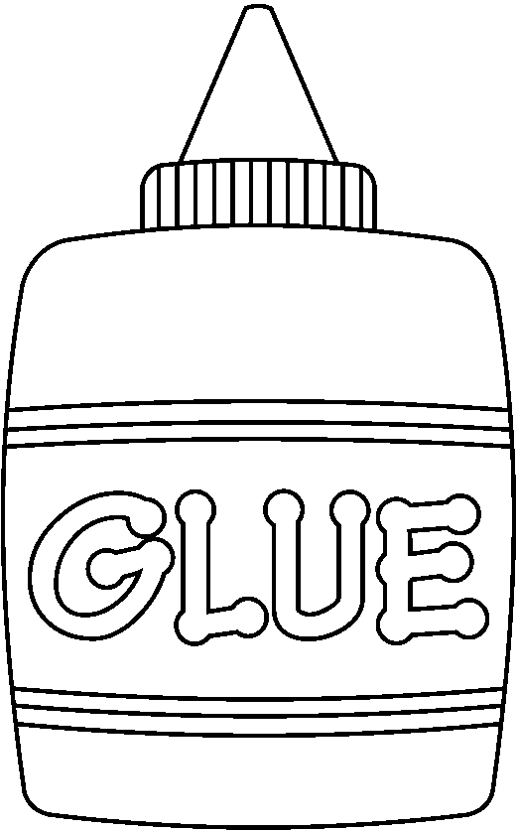](http://www.google.com.tr/url?sa=i&rct=j&q=&esrc=s&frm=1&source=images&cd=&cad=rja&docid=_pSpIwbDIL5wyM&tbnid=93vclzfClueLyM:&ved=0CAUQjRw&url=http://www.qacps.k12.md.us/ces/clipart/Carson%20Dellosa%20Clipart/Carson%20Dellosa%20Back%20to%20School/Images/Black%20and%20White%20Images/School%20Clip%20Art/&ei=3P9LUvyKO-aJ0AWXw4HgAQ&bvm=bv.53371865,d.bGE&psig=AFQjCNH9ng34lnZ7OvE4RCcmIc91bSA-vw&ust=1380798791124928) 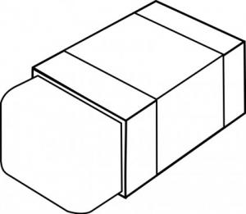  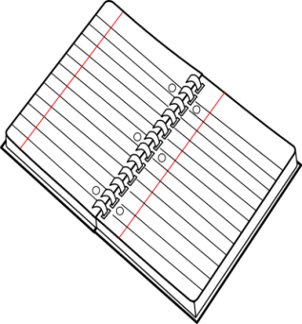

 

[](http://www.google.com.tr/url?sa=i&rct=j&q=&esrc=s&frm=1&source=images&cd=&cad=rja&docid=_pSpIwbDIL5wyM&tbnid=93vclzfClueLyM:&ved=0CAUQjRw&url=http://www.qacps.k12.md.us/ces/clipart/Carson%20Dellosa%20Clipart/Carson%20Dellosa%20Back%20to%20School/Images/Black%20and%20White%20Images/School%20Clip%20Art/&ei=3P9LUvyKO-aJ0AWXw4HgAQ&bvm=bv.53371865,d.bGE&psig=AFQjCNH9ng34lnZ7OvE4RCcmIc91bSA-vw&ust=1380798791124928)   

 

[](http://www.google.com.tr/url?sa=i&rct=j&q=&esrc=s&frm=1&source=images&cd=&cad=rja&docid=_pSpIwbDIL5wyM&tbnid=93vclzfClueLyM:&ved=0CAUQjRw&url=http://www.qacps.k12.md.us/ces/clipart/Carson%20Dellosa%20Clipart/Carson%20Dellosa%20Back%20to%20School/Images/Black%20and%20White%20Images/School%20Clip%20Art/&ei=3P9LUvyKO-aJ0AWXw4HgAQ&bvm=bv.53371865,d.bGE&psig=AFQjCNH9ng34lnZ7OvE4RCcmIc91bSA-vw&ust=1380798791124928)   

 