Name / Surname: 2019-2020 ACADEMIC YEAR
Class / Number: MİSAK-I MİLLİ ALİ ŞEFİK PRIMARY SCHOOL
FIRST TERM SECOND WRITTEN ENGLISH EXAM FOR 4th GRADES

A) Boşlukları verilen “ like ,don't like,likes,doesn’t like “ ifadeleriyle doldurunuz. (4x2=8 puan)
1. I ................................. flying a kite.
2. She .............................. reading comics.
3. I ............................... watching cartoons.
4. He ................................ playing table tennis.

B) Boş zaman etkinliklerini resimlerin altına yerleştiriniz.)(10X2=20p)
- playing table tennis - dancing - flying a kite - swimming - reading a book -

- playing with dolls - swinging - playing with marbles - riding a bike - watching cartoons

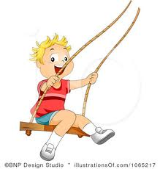
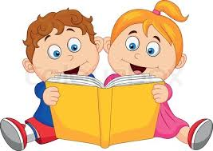
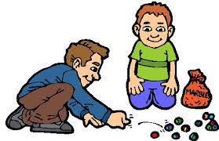

- 1.……………………..…………………. 2. …………………………….. 3. …………………………….. 4. …………………..…………. 5. ………………………….........

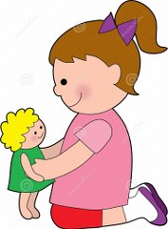
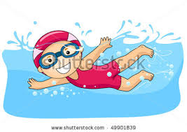
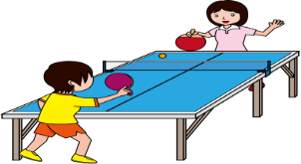
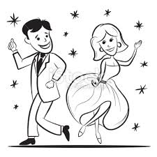
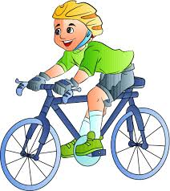

6. …………….……………... 7. ……………………………. 8. …………………………………... 9. …………..…………………. 10. ……………………………………

C) Soruları cevaplayın (5X3=15 P)

1. Do you like flying a kite? 2. Do you like riding a bike? 3. Do you like playing with marbles?
No____________________ Yes__________________ ___________________________

4. Do you like coloring a picture? 5. Do you like singing?
________________________ _______________________

D) Aşağıda verilen resimlerin altındaki soruları uygun şekilde cevaplayınız. (4x3=12 P)
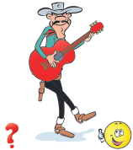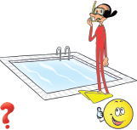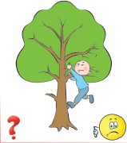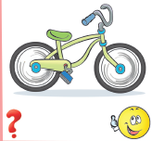
Can he play guitar? Can she swim? Can he climb a tree? Can you ride a bike?
________________ _________________ _________________ _______________

E) Aşağıdaki kelimeleri gruplandırarak doğru kutunun içine yazın (15X2=30)
ELEVEN / CLIMBING/ PENCIL / THIRTY-FIVE / PEN / NOTEBOOK / SIXTY-SEVEN / FISHING / ONE HUNDRED / BLACK / BOARD / RED / WATCHING TV / SWIMMING / PURPLE
FREE TIME ACTIVITIES
(boş zaman etkinlikleri)
COLOURS
(renkler)
CLASSROOM OBJECTS
(sınıf eşyaları)
NUMBERS
(rakamlar)

F) Aşağıdaki boşlukları “ his ya da her “ile doldurunuz. (5x1=5)

- She is Aysu. ……….. mother is a teacher.
- Ahmet is a student.This is …………… school bag.
- …………………. name is Ali Rıza.
- This is my friend. …………. name is Tuba.
- Ahmet likes animals. ……………. dog is pretty.
Güldane BÜYÜKÇAM
ENGLISH TEACHER GOOD LUCK :-)))
Güldane BÜYÜKÇAM
ENGLISH TEACHER GOOD LUCK :-)))
Güldane BÜYÜKÇAM
ENGLISH TEACHER GOOD LUCK :-)))

G) TABLOYA BAKARAK CÜMLEDEKİ BOŞLUKLARA “CAN” VEYA “CAN’T” YAZALIM (5x2=10 Points)
 |  | 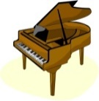 | 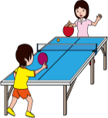 | 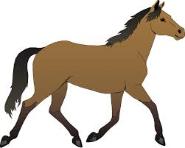  1- Aslı _________ play the guitar.  2- Enes _________ play the piano.  3- Cansu __________ play the guitar.  4- Hakan __________ ride a horse.  5- Enes __________ play table tennis.
CANSU | ✓ | ✓ | X | X
HAKAN | ✓ | ✓ | ✓ | X
ENES | X | X | ✓ | ✓
ASLI | ✓ | X | ✓ | X
