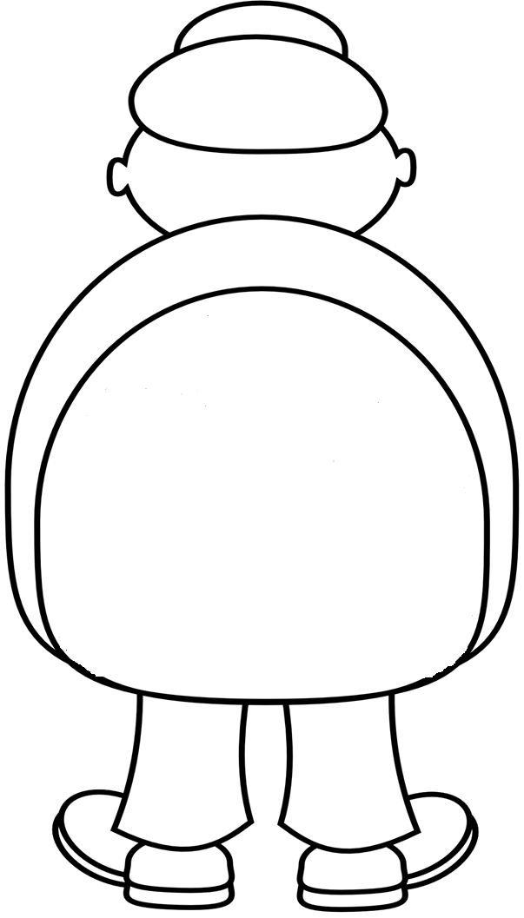

**Crayon Glue Scissors Eraser**

**Book Pencil Notebook**

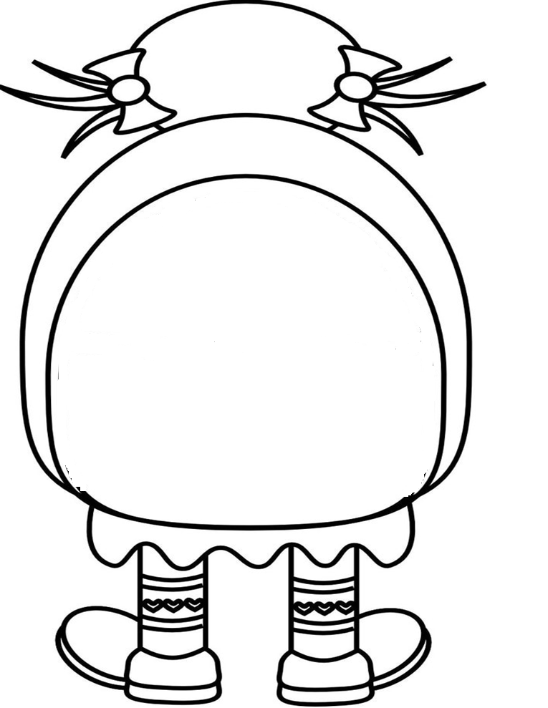

**Crayon Glue Scissors Eraser**

**Book Pencil Notebook**